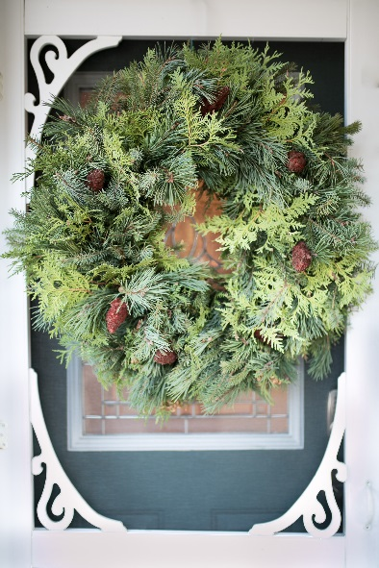
We have partnered with C.C.Farms this year for our holiday fundraiser. All profits will be used towards gym equipment and matting.
C.C. Farms
Our family run company has been producing fresh handmade evergreen Christmas products since 1997. We specialize in fresh wreaths and planters. We make everything fresh and made to order. Nothing is prepared ahead of time. We have sold directly to the public as well as to Rona Inc. We have found that there was a great partnership for our products to be used for a fundraiser for school and hockey teams.

What we make are fresh wreaths and planters. Our wreaths are made with a base of greens, spruce, white cedar and pine. We decorate the wreaths with either sumac or ilex (Ontario Holly). The size of the ring are 12” or 18” and the wreath finishes out to 20” or 24” wide and a thickness of about 5” deep.
$20.00
$30.00

Our planters are made in a plastic 2 gallon pot. They fit well
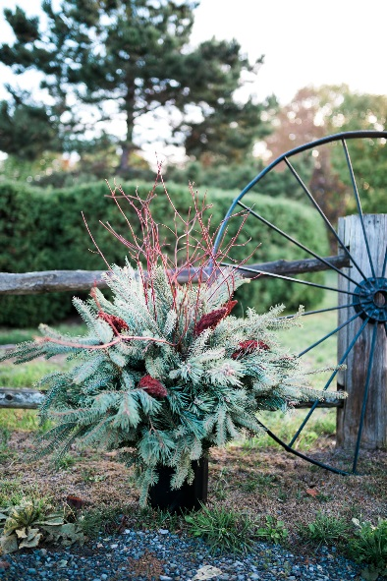
into urns. They come with a variety of spruce, white cedar, white pine, and red pine (Scotch pine). They are decorated with sumac,
ilex, and dog wood (tall red sticks) in the center.
$35.00
Everything is cut and made fresh from local products and these
products will stay green outside until spring.

All orders are due:
November 1st, 2019

Delivery date:
November 23rd between
9 -11 a.m.

Please fill out the form on the back and submit a cash payment or cheque made payable to
Quinte Bay Gymnastics with your order.
All orders must be picked up by the seller (athlete). Sellers may meet their buyers with product in the parking lot of the club.

Name & Phone # | 12” Wreath | 18” Wreath | Planter | Total
Name: Sample | 12” @ $20  x 2 = $40.00 | 18” @ $30  x 2 = $60.00 | Planter @ $35 each  x __2___ = __$70__ | $170.00
Phone #: 613- 555 1212
Name:
Phone #:
Name:
Phone #:
Name:
Phone #:
Name:
Phone #:
Name:
Phone #:
Name:
Phone #:
Name:
Phone #:
Name:
Phone #:
Name:
Phone #:
Name:
Phone #:
Name:
Phone #:
Name:
Phone #:
Name:
Phone #:
Name:
Phone #:
Name:
Phone #:
Name:
Phone #:
Totals of each | 12” Wreath @ $20  X ____= ______ | 18” Wreath @ $30 X ____= ______ | Planter @ $35 each  X _______= _______ | $
Athlete’s Name:____________________________

